CPE 324-01: Advanced Logic Design Laboratory

Lab08

Temperature Sensor

Submitted by: Esther Shore

Date of Experiment(s): April 9, 2024 and April 11, 2024

Report Deadline: April 16, 2024

1. Introduction

The objective of this lab is to develop a temperature sensor interface module capable of displaying temperature readings in both Fahrenheit and Celsius on the DE2-115 seven-segment LED displays. This entails designing a Verilog module, DS1620_INTERFACE, to interface with the DS1620 temperature sensor IC, adhering to the specified timing requirements and communication protocols outlined in the DS1620 datasheet. Additionally, we will integrate a switch to toggle between Fahrenheit and Celsius readings, along with a KEY to serve as the clear button. To validate the functionality of our temperature sensor, we will simulate the design using Questa, ensuring accurate temperature readings and reliable performance.

1. Experiment Description

Part 1: Design

The top-level design involves integrating the DS1620_INTERFACE module into the overall temperature sensor architecture, as depicted in the provided block diagram Figure 1. This integration includes connecting the DS1620_INTERFACE module to the clock input (CLK_IN), clear signal (CLR), and data input/output (DQ_IN/DQ_OUT) pins of the DS1620 IC. Additionally, the module will interface with the FPGA's internal clock and control signals, ensuring proper synchronization and communication with other components of the temperature sensor design. This involves understanding the role of each component, such as the DS1620_INTERFACE module, clock division module, and GPIO interface, in facilitating temperature sensing and display. Knowledge of digital circuit design, module integration, and signal routing is essential for interpreting the block diagram accurately.

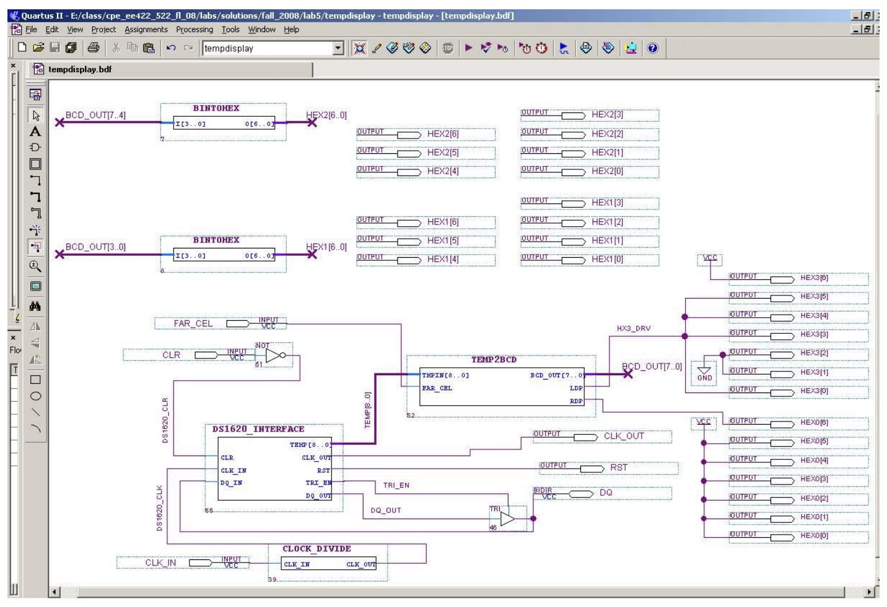

**Figure 1.** High-level structural representation of temperature sensor design

Then, we constructed the interface module to generate waveform signals based on the provided timing diagram shown in Figure 2 below, which outlines when the temperature will be read and output. This waveform programming will define the timing and sequence of signals such as clock output (CLK_OUT), reset signal (RST), tri state buffer control (TRI_EN), and data input/output (DQ_IN/DQ_OUT) to facilitate accurate temperature acquisition and communication with the DS1620 IC.

This entails crafting Verilog code to generate precise clock signals, reset pulses, and data transmission sequences according to the DS1620's communication protocol. Understanding serial communication principles, clock synchronization, and signal timing is crucial for implementing the waveform programming accurately.

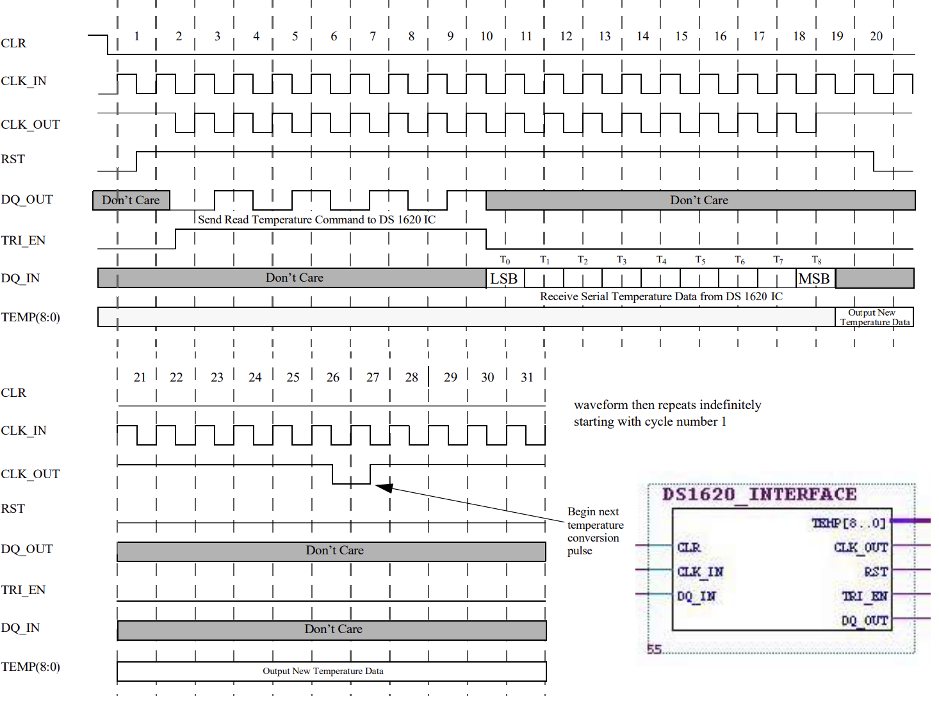

**Figure 2.** Waveforms for DS1620_INTERFACE module

The DS1620_INTERFACE module will interface with the seven-segment LED displays, toggle switch (FAR_CEL), and push button (CLR) as part of the temperature sensor design shown in Figure 3. This interface will enable the module to display temperature readings in Fahrenheit and Celsius on the LED displays based on the position of the toggle switch. The push button will serve as the clear signal, allowing the module to reset internal signals and restart the temperature acquisition process when pressed. This step involves mapping FPGA pins to the respective input and output devices and configuring GPIO interfaces.

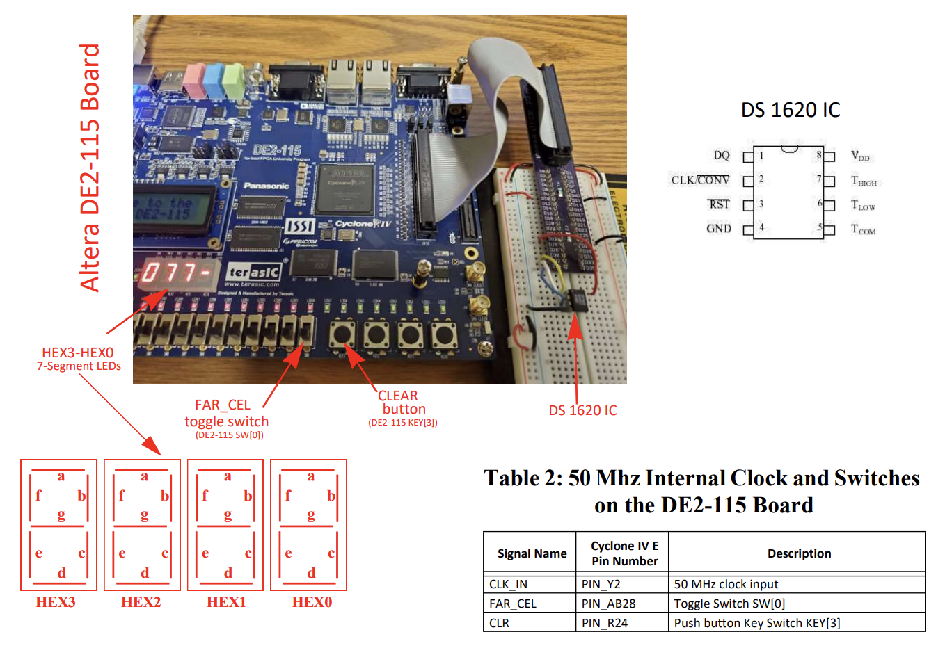

**Figure 3.** Experimental setup and features

Part 2: Simulation

In the simulation phase of the experiment, the designed DS1620_INTERFACE module will be tested using Questa simulation tool to validate its functionality and performance. The simulation will involve creating testbench code to simulate the DS1620_INTERFACE module for at least one iteration of the entire 31 cycle waveform. The simulation will verify that the module operates correctly according to the specified timing diagrams and communication protocols, ensuring any discrepancies or issues identified during simulation will be debugged and resolved to ensure the final design meets the project requirements.

1. Demonstration

Part 1: Design

For our demonstration, we showcased how the Verilog code for the interface module was crafted to adhere to the waveform timing diagram provided. Specifically, we will highlight how the code accurately generates clock pulses, reset signals, and data transmissions in synchronization with the rising and falling edges specified in the timing diagram. By meticulously aligning the code with the timing requirements, we ensure that the interface module communicates effectively with the DS1620 temperature sensor, enabling precise temperature readings to be captured and displayed on the DE2-115 seven-segment LED displays. Our code is shown in Figure 4 below.

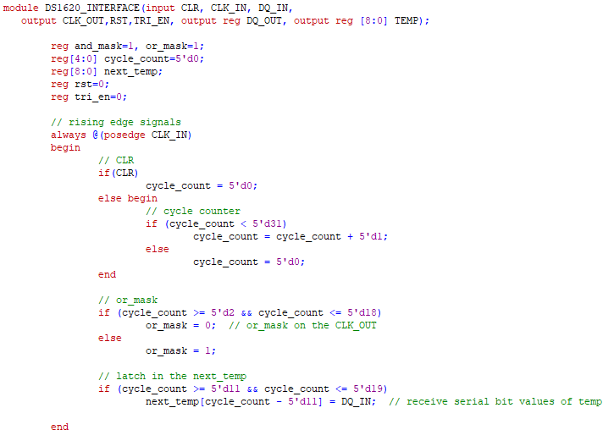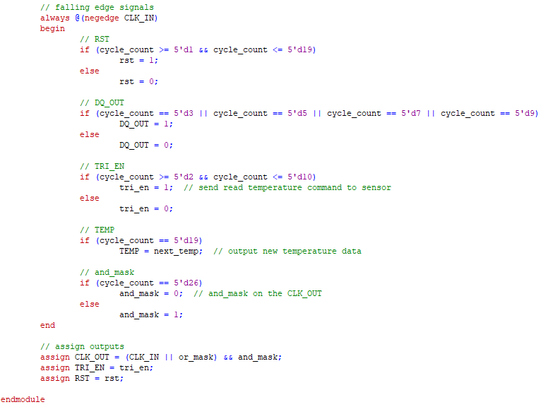

**Figure 4.** DS1620_INTERFACE code

Part 2: Simulation

For our testbench creation for the Questa simulation, we opted to utilize a timescale of 1us to simulate a CLK_IN frequency of 1kHz using a parameter of 1000 timescale units. Then, we employed an always statement to toggle the CLK_IN signal every half period, ensuring that the simulation accurately reflects the behavior of the clock signal consistently over time. This approach enables us to verify the functionality of our design under the specified timing constraints and assess its performance comprehensively.

We started by setting the CLR input to logic 1 for a singular clock cycle and then setting the CLR to logic 0 and allowing our simulation to run for a full 31 cycle waveform, resulting in a simulation time of 32ms. We also tested by sending the bits of a test temperature 25C to DQ_IN over 9 cycles, accounting for the first bit representing the 0.5 place. This was done on the falling edge of the input clock cycle. In order to assure our desired waveform was being displayed properly, we also had to check the simulation resolution and set it to an appropriate value less than half a period. Our complete testbench code is shown in Figure 5 below.

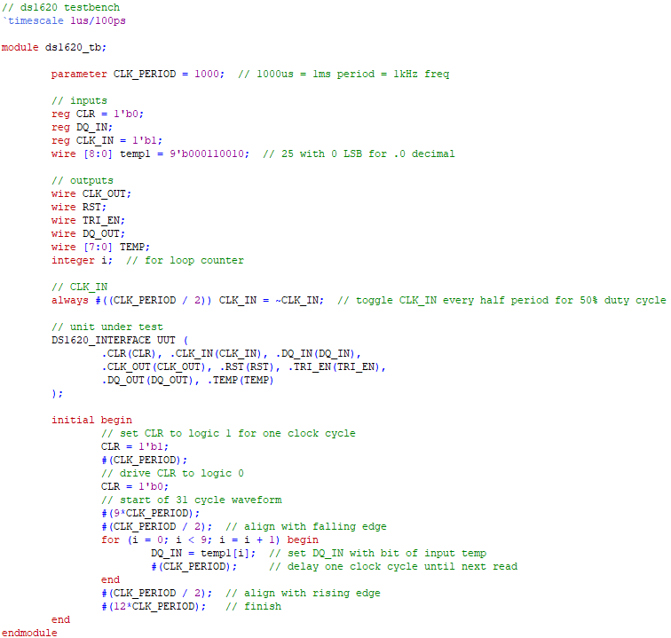

**Figure 5.** Testbench code

1. Experimental Results

Part 1: Design

We successfully observed the temperature readings from the sensor displayed on the DE2 hex display. With the toggle switch seamlessly transitioning between Fahrenheit and Celsius modes, we captured photos illustrating the display for both scales, which can be seen in Figures 6 and 7. Additionally, we tested the dynamic temperature change by placing our finger on the sensor, resulting in an elevated temperature reading displayed on the hex display as shown in Figure 8. The functionality of the CLR hold button was also verified, resetting the system and acquiring a new temperature reading upon release, effectively showcasing its operational capability.

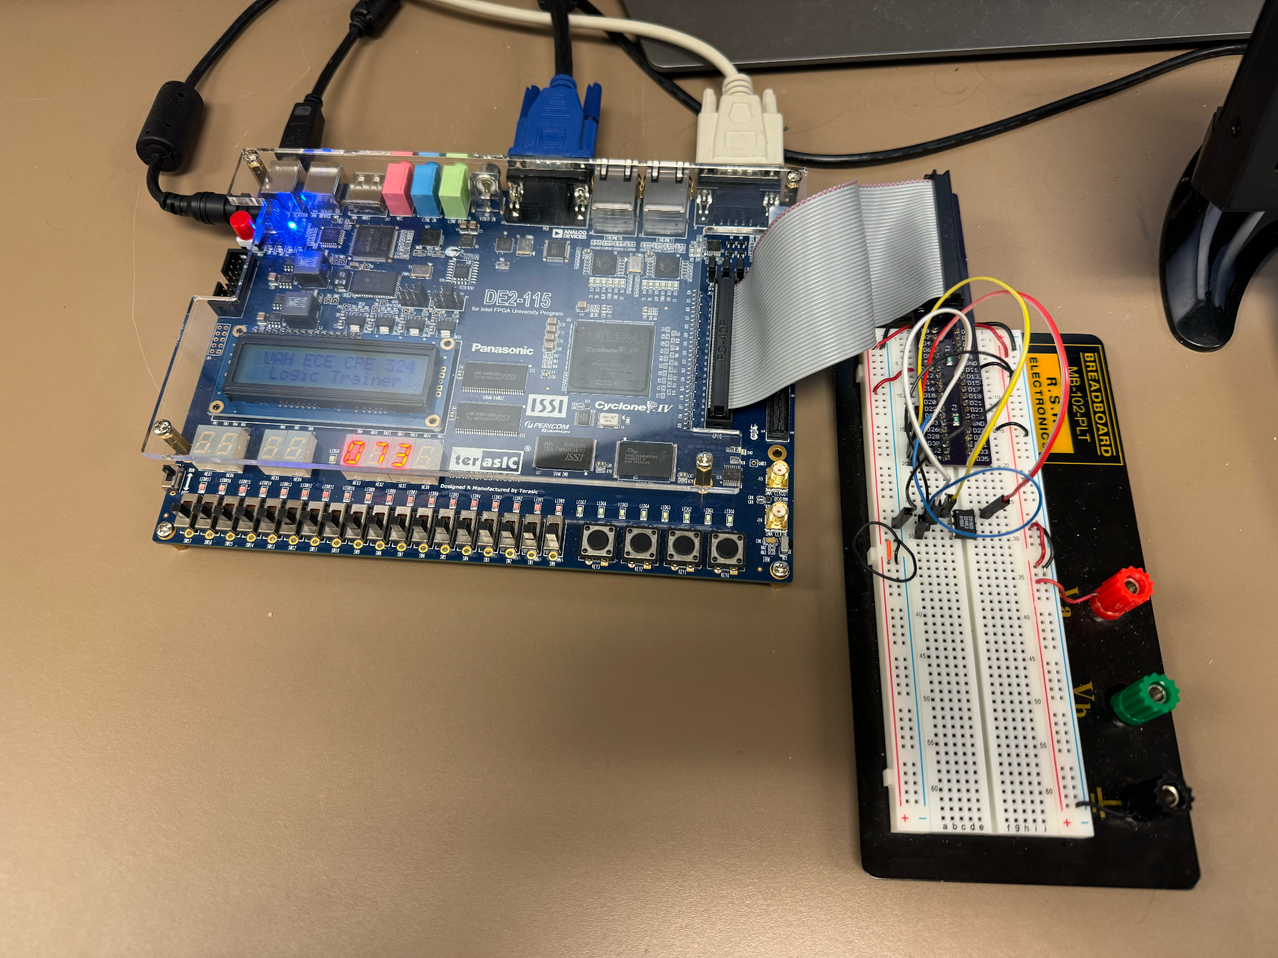

**Figure 6.** Room temperature in Fahrenheit

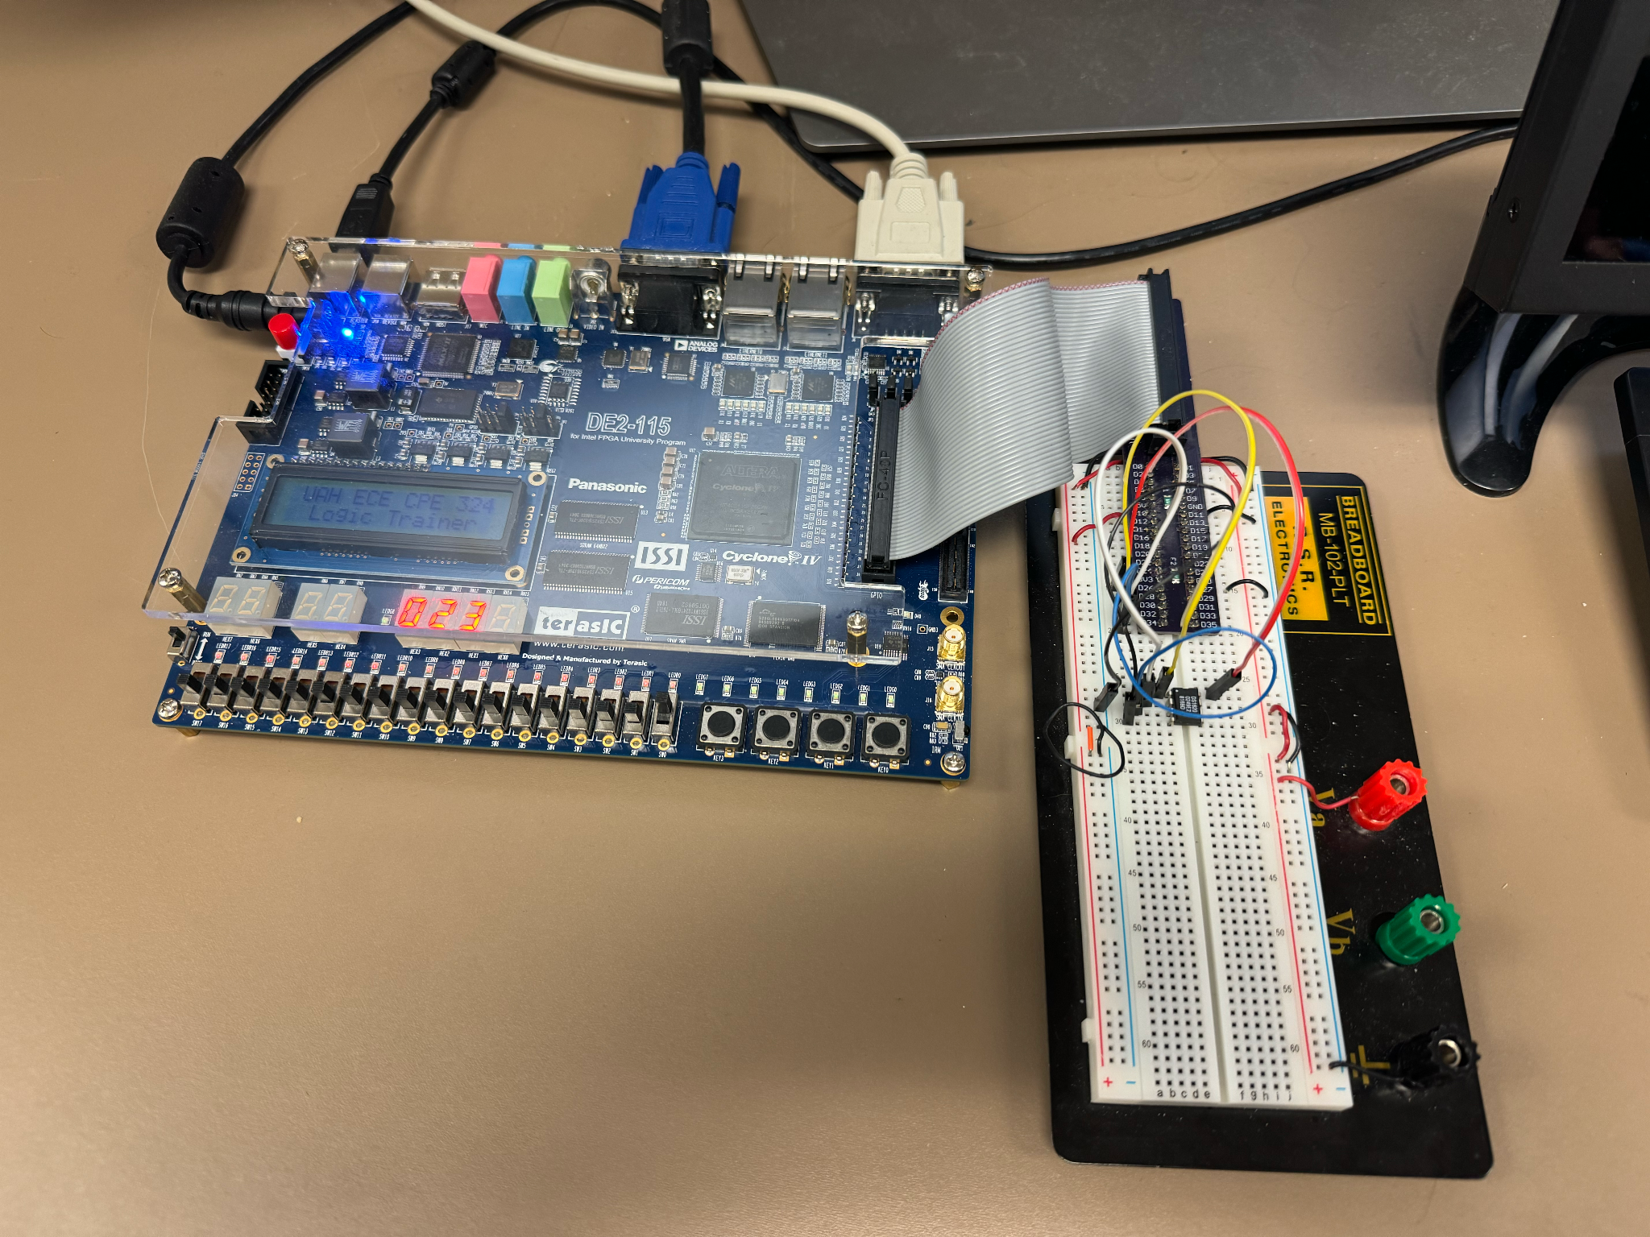

**Figure 7.** Room temperature in Celsius

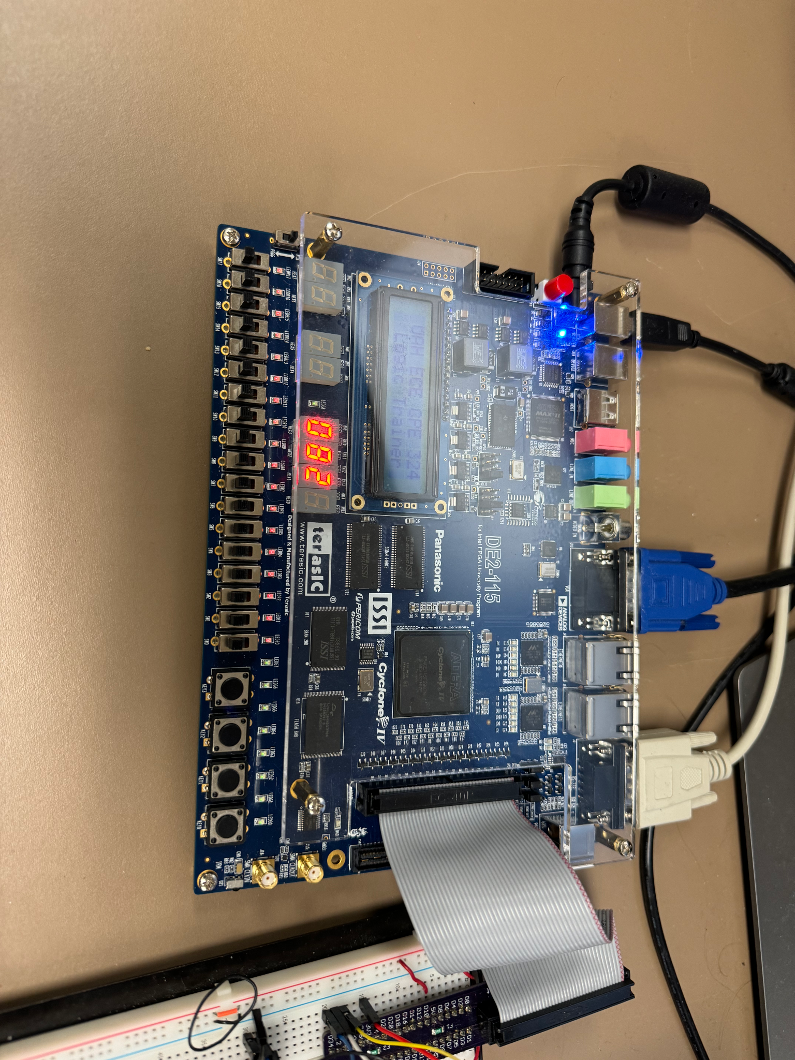

**Figure 8.** High temperature

Part 2: Simulation

After successful simulation, we provided the output waveforms generated from our simulation in Figure 9, demonstrating its alignment with the expected waveform timing diagram guide as outlined in the experiment description section. The simulated signals accurately reflected the specified timing requirements and communication protocols described in the design specifications. We also saw the expected two times the input temperature on the TEMP output after loading our bit values through DQ_IN due to the resolution of the temperature in 1 ⁄ 2 degree Celsius. This validation confirms the correct implementation of our Verilog module and its adherence to the prescribed functionality.

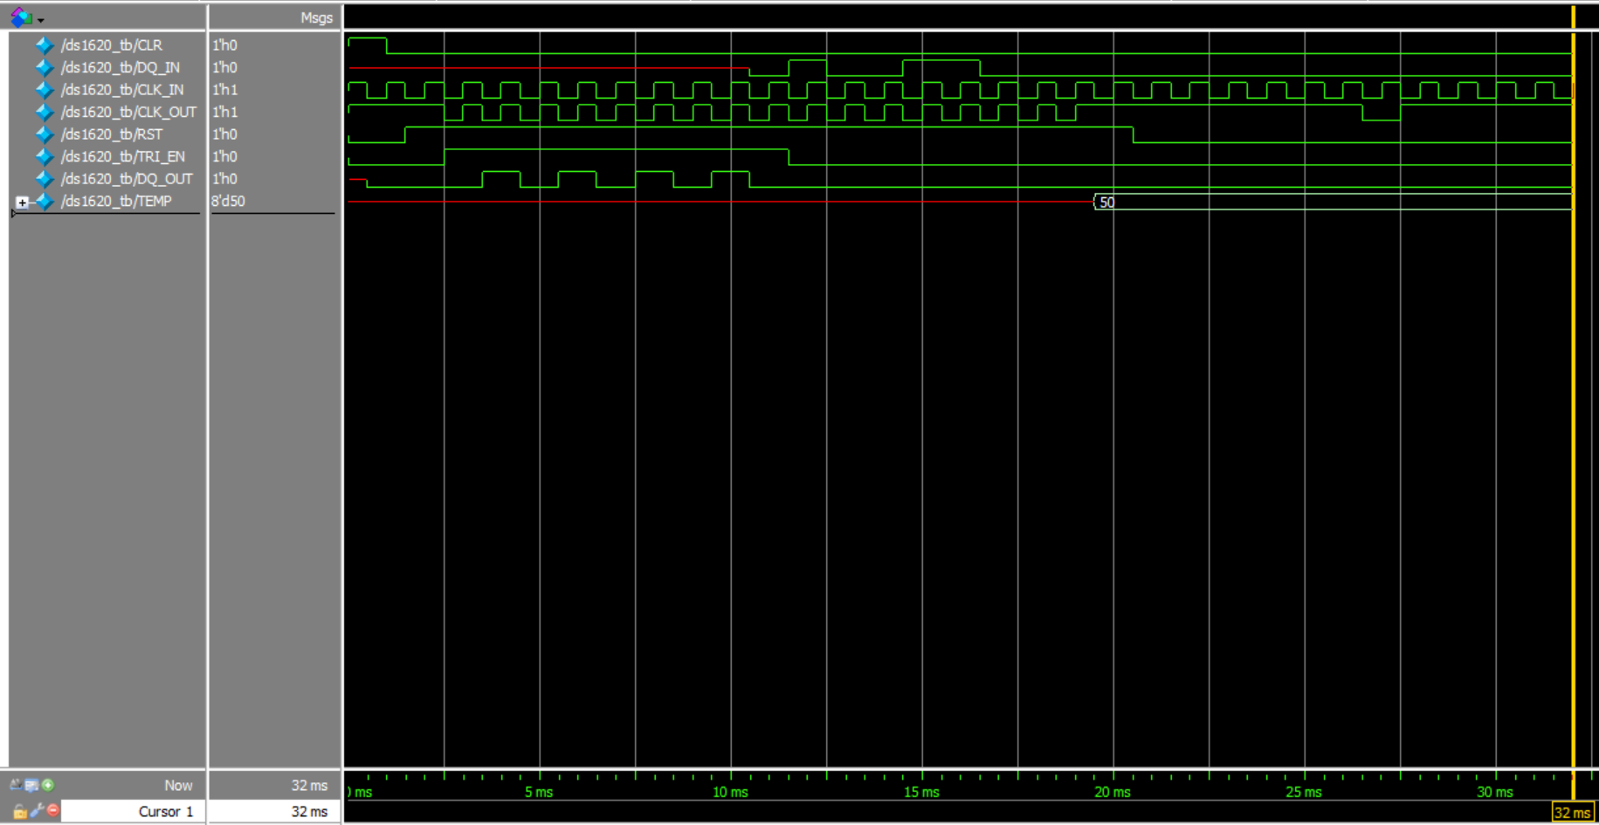

**Figure 9.** Simulated waveforms

Question

1. Rewrite a functionally equivalent TEMP2BCD module in Verilog that could interface directly with the rest of the testbench design.

| module TEMP2BCD(  input [8:0] TMPIN,  input FAR_CEL,  output reg [7:0] BCD_OUT,  output reg LDP,  output reg RDP  );  reg [8:0] BCD_CEL;  reg [8:0] BCD_FAR;  always @(*) begin  RDP = ~TMPIN[0];  if (FAR_CEL == 1'b0) begin  LDP = BCD_FAR[8];  BCD_OUT = BCD_FAR[7:0];  end else begin  LDP = BCD_CEL[8];  BCD_OUT = BCD_CEL[7:0];  end  end  always @(TMPIN) begin  case(TMPIN[7:1])  7'b0000000: BCD_CEL <= 9'b000000000;  7'b0000001: BCD_CEL <= 9'b000000001;  7'b0000010: BCD_CEL <= 9'b000000010;  // and so on, rest of conversions from CEL to BCD  endcase  case(TMPIN[7:0])  8'b00000000: BCD_FAR <= 9'b000110010;  8'b00000001: BCD_FAR <= 9'b000110010;  8'b00000010: BCD_FAR <= 9'b000110011;  // and so on, rest of conversions from FAR to BCD  endcase  end  endmodule |
| --- |

1. Conclusion

This laboratory provided valuable hands-on experience in developing a temperature sensor interface module using Verilog. By integrating the DS1620_INTERFACE module and simulating its functionality, we demonstrated the ability to accurately acquire and display temperature readings in both Fahrenheit and Celsius on the DE2-115 seven-segment LED displays. The successful design and simulation validate our understanding of digital circuit design principles and our ability to implement complex interfaces in FPGA-based systems. Additionally, interpreting and understanding the signal waveforms generated during simulation provided valuable insights into the timing requirements and communication protocols, further enhancing our comprehension of digital circuit design principles.